UART PROTOCOL
- Explanation
Universal Asynchronous Receiver Transmitter (UART) is a widely used hardware communication protocol that enables asynchronous serial data transfer between digital devices. Unlike synchronous communication methods, UART does not use a shared clock signal between the transmitter and the receiver. Instead, both sides operate with a predefined baud rate, which determines the duration of each transmitted bit.
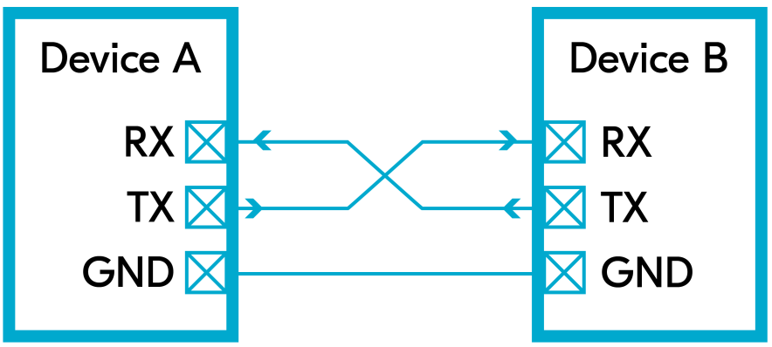

Figure 1: Physical UART connection between two devices showing TX, RX and common ground lines.

Figure 1 shows the basic physical connection of two UART-enabled devices. Each device has a transmit (TX) and a receive (RX) line. The TX pin of one device is connected to the RX pin of the other device, while both systems share a common ground (GND). This cross-connection allows full-duplex communication between the two devices.
UART communication is based on framing the data with control bits. A general UART frame structure is illustrated in Figure 2.
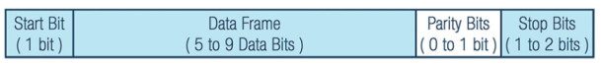

Figure 2: General UART frame structure including start bit, data bits, optional parity bit and stop bit(s).

As shown in the figure, a UART frame typically consists of:
- one start bit,
- 5 to 8 data bits,
- an optional parity bit, and
- one or two stop bits.
In this project, the frame format is selected as 1 start bit, 8 data bits, no parity, and 1 stop bit (8N1), which is one of the most commonly used configurations.

The timing behavior of a UART transmission is presented in Figure 3.

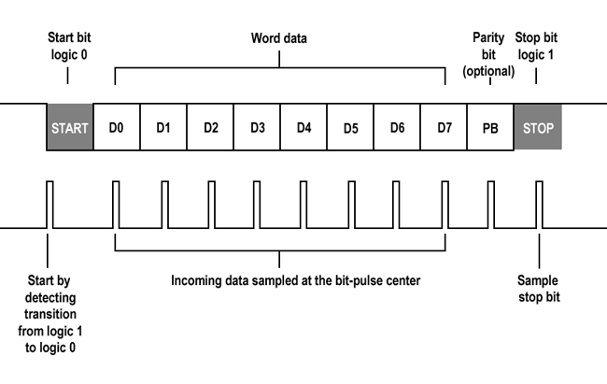

Figure 3: UART timing diagram illustrating start bit detection and sampling of data bits at the center of each bit period.

During the idle state, the UART line is held at logic ‘1’. Communication begins when the transmitter pulls the line to logic ‘0’, indicating the start bit. After that, the data bits are transmitted starting from the least significant bit (LSB). The receiver detects the falling edge of the start bit and then samples the incoming data at the center of each bit period. After all data bits are received, the stop bit returns the line to logic ‘1’, marking the end of the frame.

To handle asynchronous timing, the receiver generally uses oversampling. In this project, the receiver samples the incoming data at 8 times the baud rate and determines each bit value by comparing the number of sampled logic ‘1’s and logic ‘0’s within one bit duration.

Figure 4 illustrates how parallel data is converted into serial form in the UART transmitter.

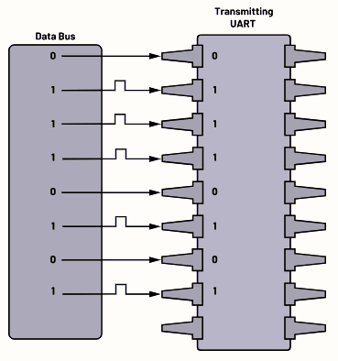

Figure 4: Parallel-to-serial data conversion performed by the UART transmitter.

The transmitter takes an 8-bit parallel input from the data bus and shifts it out bit by bit according to the baud rate. Similarly, the UART receiver performs the inverse operation by reconstructing the serial data stream back into an 8-bit parallel word.

The reverse operation is performed in the UART receiver, as illustrated in Figure 5. The receiver collects the incoming serial data bits from the RX line and reconstructs them into an 8-bit parallel word on the data bus. Each bit is sampled at the appropriate time instant, and after all data bits are received, the complete parallel data is made available at the output of the receiver.

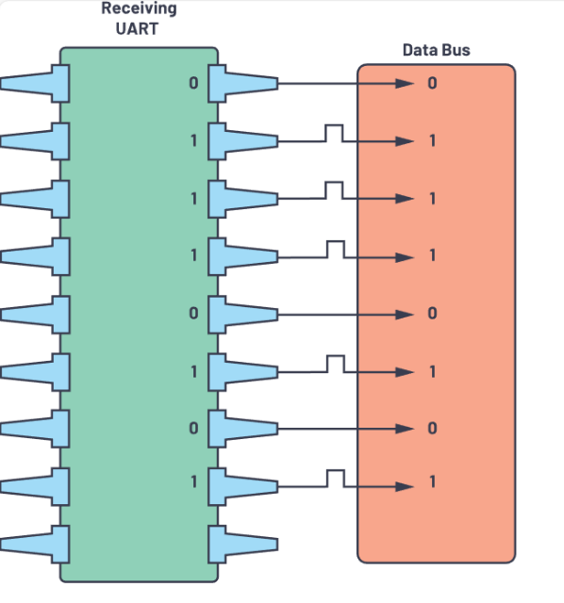

Figüre 5: Serial-to-parallel data reconstruction performed by the UART receiver.

Overall, UART offers a simple and efficient method for serial communication with minimal wiring requirements. Its asynchronous nature and configurable frame structure make it suitable for a wide range of digital and embedded system applications.

- Algorithm

In this project, the UART driver is designed in a modular structure consisting of four main blocks: uart_tx, uart_rx, baud_gen, and uart_top. Each module is responsible for a specific task in the overall communication process.

The baud_gen module generates the required baud rate and its oversampled version from the system clock. This module provides timing references for both the transmitter and the receiver.

The uart_tx module implements the transmitter side of the UART protocol. It takes 8-bit parallel data as input and sends it serially according to the UART frame format using a finite state machine structure.

The uart_rx module performs the reverse operation. It receives serial data from the RX line, samples it using the oversampled baud clock, and reconstructs the original 8-bit parallel data at its output.

Finally, the uart_top module acts as the top-level integration block where the transmitter, receiver, and baud rate generator modules are instantiated and interconnected. It provides a single interface for external control signals and data input/output.

This modular design improves readability, reusability, and ease of debugging, while also allowing each block to be verified independently through simulation.

- Baud Rate Generator Module

The UART design requires two timing references: the baud rate clock used for bit-to-bit progression, and an oversampled clock used by the receiver for reliable sampling. Therefore, the baud rate generator is designed to produce baud and 8x baud timing pulses from the internal 100 MHz system clock.
The module is parameterized by the baud rate value (BAUD) and generates a one-clock-cycle pulse called tick_8x every:
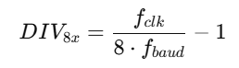

where $f_{clk}=100 MHz$and $f_{baud}$is selected as 115200 or 9600 in this project. Each time tick_8x is asserted, an internal modulo-8 counter is increased. When eight tick_8x pulses occur, the module produces a second one-clock-cycle pulse called tick_baud, which represents the actual baud timing.
An enable signal (en) is used to start/stop the divider operation. When en = 0, counters are cleared so that the timing restarts deterministically when enabled again. This behavior is especially useful for the receiver side, where sampling is aligned after detecting the start bit.
Verification:
The module is simulated for both baud rates. For 115200, the expected divider for the oversampled tick is:
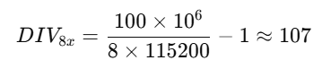

For 9600, the expected value is:

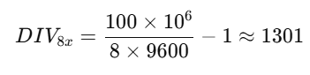

In the simulation waveform, tick_8x appears periodically according to the computed divider value, and tick_baud is observed once for every eight tick_8x pulses, confirming correct operation.

  - Design Source

`timescale 1ns / 1ps

module baud_gen #(
parameter [16:0] freq = 115200 // Target Baud Rate
)
(
input wire clk, // System Clock
input wire rst, // Reset Signal (Active High)
input wire baud_en, // Module Enable Signal
output wire count_8x_ready, // Pulse for 8x oversampling (Receiver)
output wire count_baud_ready // Pulse for standard baud rate (Transmitter)
);

// Internal Constants
// System clock frequency set to 100 MHz
localparam integer clk_freq = 100_000_000;

// Internal Registers
reg count_8x_ready_reg;
reg count_baud_ready_reg;

// Counter for the 8x tick generation
// 14 bits are enough for standard baud rates at 100MHz
reg [13:0] counter_8x;

// Counter to divide 8x ticks down to 1x (counts 0 to 7)
reg [2:0] counter_baud;

always @(posedge clk) begin
// 1. Reset Logic
if (rst == 1'b1) begin
counter_baud <= 3'b0; // Reset baud counter
count_baud_ready_reg <= 1'b0; // Clear baud output
counter_8x <= 14'b0; // Reset 8x counter
count_8x_ready_reg <= 1'b0; // Clear 8x output
end
// 2. Active Logic (When enabled)
else if (baud_en == 1'b1) begin
// Calculate limit: (Clock / (Baud * 8)) - 1
// Check if 8x counter reached the limit
if (counter_8x == ((clk_freq / (freq * 8)) - 1)) begin
counter_8x <= 14'b0; // Reset counter
count_8x_ready_reg <= 1'b1; // Generate 8x pulse

// Manage the Standard Baud Counter (0 to 7)
if (counter_baud == 3'd7) begin
counter_baud <= 3'b0;
count_baud_ready_reg <= 1'b1; // Generate Baud pulse
end
else begin
counter_baud <= counter_baud + 1'b1;
count_baud_ready_reg <= 1'b0;
end
end
else begin
// Increment 8x counter, keep outputs low
counter_8x <= counter_8x + 1'b1;
count_8x_ready_reg <= 1'b0;
count_baud_ready_reg <= 1'b0;
end
end
// 3. Disable Logic
else begin
count_8x_ready_reg <= 1'b0;
counter_8x <= 14'b0;
// FIXED: Originally 13'b0, changed to 3'b0 to match register width
counter_baud <= 3'b0;
count_baud_ready_reg <= 1'b0;
end
end

// Assign internal registers to output ports
assign count_8x_ready = count_8x_ready_reg;
assign count_baud_ready = count_baud_ready_reg;

endmodule

  - Testbench Code

`timescale 1ns / 1ps // Simulation timescale: 1ns unit step with 1ps precision

module baud_gen_tb();

// Parameters
// 115200 requires 17 bits (2^17 = 131072), so [16:0] is sufficient.
parameter [16:0] freq = 115200;

// Testbench Signals
// Inputs to the DUT are defined as 'reg'
reg clk = 1'b0;
reg rst = 1'b0;
reg baud_en = 1'b0; // Enable control signal

// Outputs from the DUT are defined as 'wire'
wire count_8x_ready; // 8x oversampling clock pulse
wire count_baud_ready; // Standard baud rate clock pulse

// Instantiate the DUT (Device Under Test)
baud_gen #(
.freq(freq) // Pass the frequency parameter to the module
) uut (
.clk(clk),
.rst(rst),
.baud_en(baud_en),
.count_8x_ready(count_8x_ready),
.count_baud_ready(count_baud_ready)
);

// Clock Generation
// Generate a 100 MHz clock (Period = 10 ns).
// Toggles every 5 ns.
always begin
#5 clk = ~clk;
end

// Stimulus Process
initial begin
// 1. Initialize Inputs
rst = 1; // Assert reset (active high)
baud_en = 0; // Keep module disabled initially

// 2. Apply Reset
#10; // Wait for 10 ns
rst = 0; // De-assert (release) reset

// 3. Enable Operation
baud_en = 1; // Enable the baud rate generator

// 4. Run Simulation
#11000; // Let it run for 11,000 ns (11 us)

// 5. Disable Operation
baud_en = 0; // Disable the generator to verify stop behavior

// 6. Finish Simulation
#200; // Wait a bit more for stability
$finish; // Stop the simulation
end

endmodule

  - Simulation Waveform

For 115200Hz:

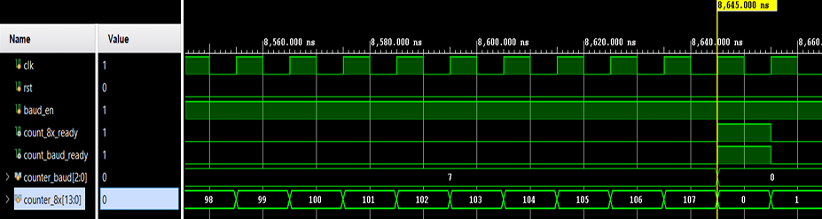

Figure 6: Simulation waveform of baud_gen for 115200 baud showing tick_8x and tick_baud pulses.

For 9600Hz:
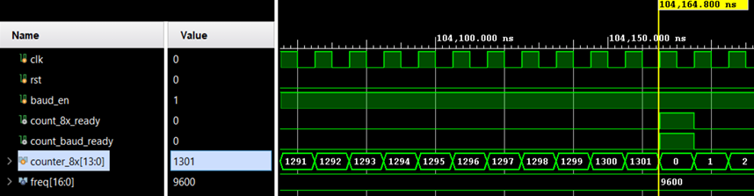

Figure 7: Simulation waveform of baud_gen for 9600 baud showing tick_8x and tick_baud pulses.

- UART Transmitter

The uart_tx module is responsible for transmitting an 8-bit parallel input as a serial UART frame. The frame format used in this project is 1 start bit, 8 data bits (LSB first), and 1 stop bit. The transmitter is implemented using a finite state machine (FSM) with four states: IDLE, START, DATA, STOP.
- IDLE: The TX line is held at logic ‘1’. The module waits for tx_en to become high. When tx_en is asserted, the input byte is latched into an internal register and the baud generator is enabled (baud_en = 1). A one-cycle start pulse is generated to indicate the beginning of a transmission.
- START: The transmitter drives the line low (tx_out = 0) for exactly one baud period to send the start bit.
- DATA: The transmitter sends the data bits sequentially. The least significant bit is transmitted first. The bit progression is controlled by the tick_baud signal (a one-cycle pulse from the baud rate generator). At each tick_baud, the next bit is output and the internal shift register is updated. After 8 bits, the FSM transitions to STOP.
- STOP: The line is driven high (tx_out = 1) for one baud period as the stop bit. After that, the transmitter disables the baud generator, generates a one-cycle done pulse, and returns to IDLE.
During the transmission process, the busy signal remains high to indicate that the module is actively sending a frame.

  - Design Source

`timescale 1ns / 1ps

module uart_tx #(
parameter [16:0] freq = 115200 // Baud rate parameter
)
(
input wire clk, // System clock
input wire rst, // Reset (Active High)
input wire [7:0] d_in, // Data to be transmitted
input wire tx_en, // Start transmission signal
output wire seri_out, // Serial data output (Tx pin)
output reg start, // Status: Start bit being sent
output reg busy, // Status: Module is busy
output wire done // Status: Transmission complete
);

// Internal Signals
wire count_baud_ready; // Baud tick from generator
wire out_of_use; // Unused 8x tick
reg done_reg; // Register for done signal
reg seri_out_reg; // Register for serial output
reg baud_en; // Enable signal for baud generator
reg [2:0] bit_in; // Bit counter (0 to 7)
reg [7:0] buffer; // Data buffer (Shift register)

// State Machine Definitions
localparam IDLE = 2'b00;
localparam START = 2'b01;
localparam DATA = 2'b10;
localparam STOP = 2'b11;

reg [1:0] state;

// Instantiate Baud Rate Generator
baud_gen #(
.freq(freq)
) divider (
.clk(clk),
.rst(rst),
.baud_en(baud_en),
.count_8x_ready(out_of_use), // Not needed for TX
.count_baud_ready(count_baud_ready)
);

// Main State Machine
always @(posedge clk) begin
if (rst == 1'b1) begin
state <= IDLE;
done_reg <= 0;
start <= 0;
busy <= 0;
seri_out_reg <= 1; // Idle state is High (1)
baud_en <= 0;
bit_in <= 0;
buffer <= 8'b0;
end
else begin
case(state)
// State 0: Wait for tx_en signal
IDLE: begin
done_reg <= 0;
seri_out_reg <= 1; // Tx line High when idle
baud_en <= 0;
busy <= 0;
start <= 0;

if (tx_en == 1) begin
state <= START;
buffer <= d_in; // Load data into buffer
bit_in <= 0; // Reset bit counter
end
end

// State 1: Send Start Bit (Low)
START: begin
start <= 1;
seri_out_reg <= 0; // Start bit is always 0
baud_en <= 1; // Turn on baud generator
busy <= 1;

// Wait for one baud period
if(count_baud_ready == 1) begin
state <= DATA;
end
end

// State 2: Send Data Bits (LSB First)
DATA: begin
start <= 0;
busy <= 1;
seri_out_reg <= buffer[0]; // Send LSB

if(count_baud_ready == 1) begin
if(bit_in == 7) begin
state <= STOP;
bit_in <= 0;
end
else begin
buffer <= buffer >> 1; // Shift right to get next bit
bit_in <= bit_in + 1;
end
end
end

// State 3: Send Stop Bit (High)
STOP: begin
seri_out_reg <= 1; // Stop bit is always 1

if(count_baud_ready == 1) begin
state <= IDLE;
baud_en <= 0; // Turn off baud generator
busy <= 0;
done_reg <= 1; // Signal completion
end
end

default: begin
state <= IDLE;
end
endcase
end
end

// Output assignments
assign done = done_reg;
assign seri_out = seri_out_reg;

endmodule

  - Finite State Machine
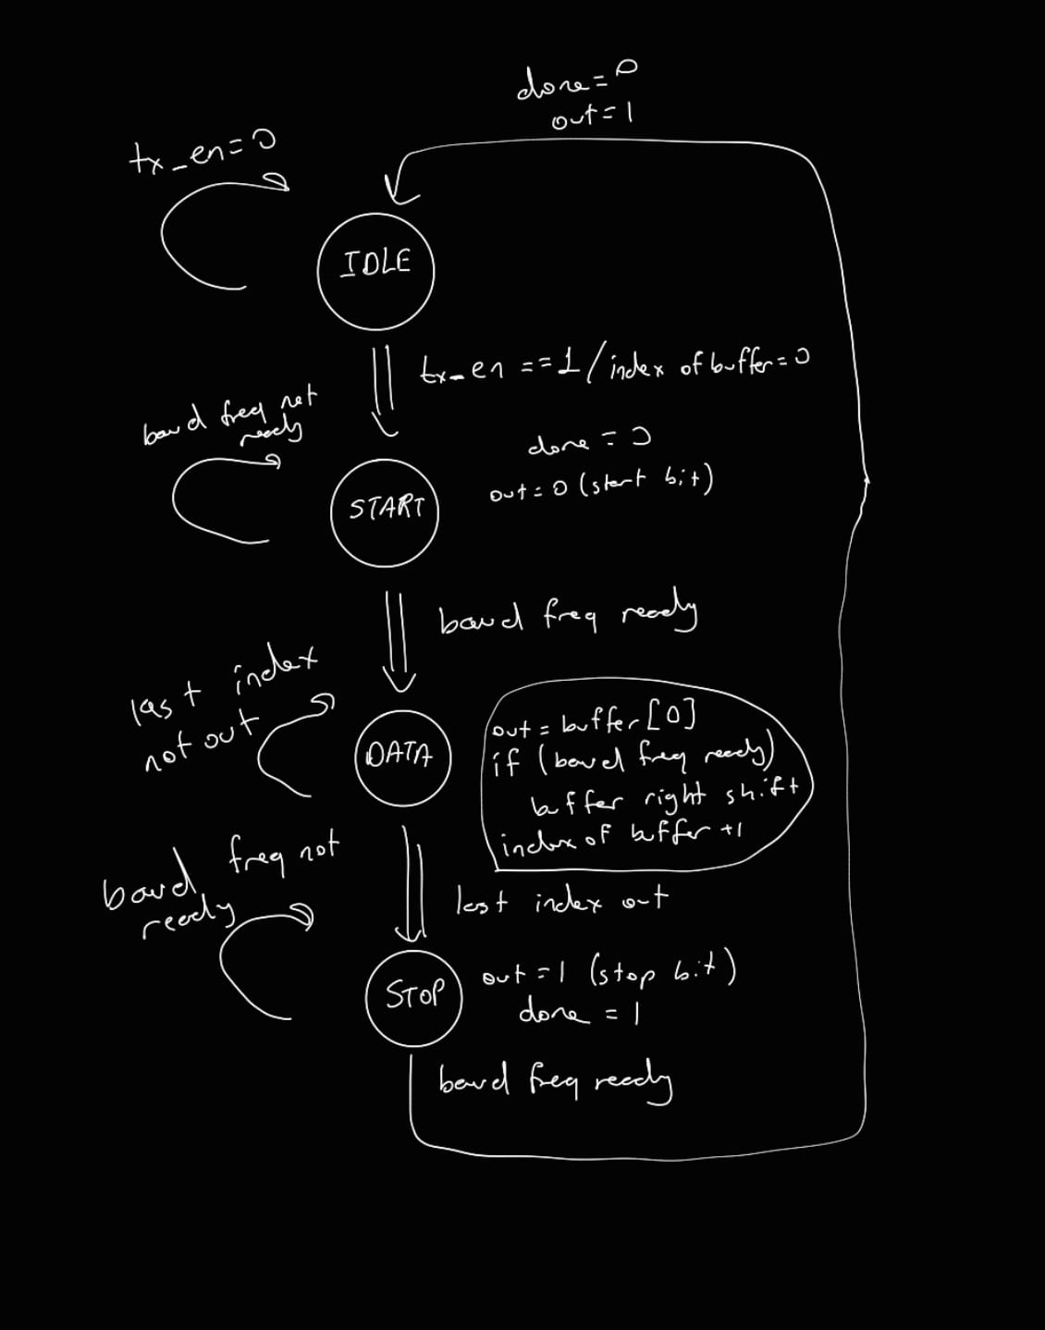

  - Simulation Source
module uart_tx_tb;

// Parameters
parameter [16:0] freq = 115200;

// Testbench Signals
reg clk = 1'b0;
reg rst = 1'b0;
reg [7:0] d_in;
reg tx_en = 1'b0;

// Outputs from DUT
wire seri_out;
wire done;
wire start; // Added to match DUT
wire busy; // Added to match DUT

// File I/O Variables
integer file, r;
reg [7:0] stimulus_data;
integer i;

// Instantiate the Unit Under Test (UUT)
uart_tx #(
.freq(freq)
) uut (
.clk(clk),
.rst(rst),
.d_in(d_in),
.tx_en(tx_en),
.seri_out(seri_out),
.start(start), // Connected for observation
.busy(busy), // Connected for observation
.done(done)
);

// Clock Generation
// 100 MHz clock (10ns period -> toggle every 5ns)
always #5 clk = ~clk;

// Main Stimulus Process
initial begin
// 1. Open the file
// Ensure "stimulus2.txt" exists in the simulation directory
file = $fopen("stimulus2.txt", "r");
if (file == 0) begin
$display("Error: Cannot open stimulus2.txt");
$finish;
end

// 2. Initialize and Reset
rst = 1;
d_in = 8'b0;
tx_en = 0;

#8000; // Wait 8us (long reset)
rst = 0; // Release reset

// 3. Read loop
// Reads 4 lines of binary data from the file
for (i = 0; i < 4; i = i + 1) begin
// Read binary data (%b) into variable
r = $fscanf(file, "%b\n", stimulus_data);

if (r == 1) begin // If read was successful

// Drive new data
d_in = stimulus_data;

// Generate Enable Pulse (1 clock cycle)
tx_en = 1;
#10;
tx_en = 0;

// Wait for transmission to complete
wait (done == 1);

// Wait before sending the next byte
#15000;
end
end

// 4. Cleanup
$fclose(file);
$finish;
end

endmodule
I write 4 data into a text file as each one 8 bits. I used them in the simulation and checked it.
Here they are:
00101011
11000100
11110011
01001110

  - Simulation Waveform
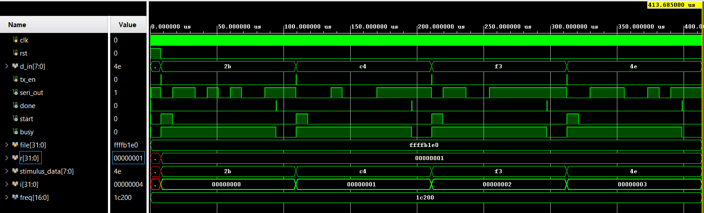

Figure 8: UART transmitter simulation waveform for input bytes 0x2B, 0xC4, 0xF3 and 0x4E, showing start bit, data bits (LSB first) and stop bit together with control signals.

2b = 0010 1011₂ → LSB first: 1 1 0 1 0 1 0 0
c4 = 1100 0100₂ → LSB first: 0 0 1 0 0 0 1 1
f3 = 1111 0011₂ → LSB first: 1 1 0 0 1 1 1 1
4e = 0100 1110₂ → LSB first: 0 1 1 1 0 0 1 0

In the transmitter simulation, the input bytes 0x2B, 0xC4, 0xF3 and 0x4E are applied through the stimulus file. As shown in Figure X, each value is transmitted with a start bit, followed by 8 data bits in LSB-first order, and a stop bit. The busy signal stays high during the frame, while done pulses at the end of each transmission, confirming the correct operation of the UART transmitter.

- UART Receiver
  - Design Source

module uart_rx #(
parameter [16:0] freq = 115200
)
(
input wire clk, // System Clock
input wire rst, // Reset (Active High)
input wire d_in, // Serial Data Input (Rx Pin)
input wire rx_en, // Receiver Enable Signal
output wire [7:0] d_out, // Parallel Data Output
output reg start, // Status: Start bit detected
output reg busy, // Status: Receiver is busy
output wire done // Status: Reception complete
);

// Internal Registers
reg [3:0] count_ones; // Counter for logic '1' samples
reg [3:0] count_zeros; // Counter for logic '0' samples
reg [2:0] counter_halfperiod; // Counts to find center of start bit
reg [7:0] d_out_reg; // Shift register for data
reg [3:0] bit_in; // Bit index counter (0-7)
reg done_reg; // Internal done signal
reg baud_en; // Control for Baud Generator

// Wires
wire count_baud_ready; // Full bit period tick
wire count_8x_ready; // 8x oversampling tick

// State Machine Definitions
localparam IDLE = 2'b00;
localparam START = 2'b01;
localparam DATA = 2'b10;
localparam STOP = 2'b11;

reg [1:0] state;

// Instantiate Baud Rate Generator
baud_gen #(
.freq(freq)
) divider (
.clk(clk),
.rst(rst),
.baud_en(baud_en),
.count_8x_ready(count_8x_ready),
.count_baud_ready(count_baud_ready)
);

// Main State Machine
always @(posedge clk) begin
if (rst == 1'b1) begin
state <= IDLE;
done_reg <= 0;
start <= 0;
busy <= 0;
baud_en <= 0;
counter_halfperiod <= 3'b0;
count_ones <= 0;
count_zeros <= 0;
d_out_reg <= 8'b0;
bit_in <= 0;
end
else begin
case(state)

// State 0: Wait for Enable
IDLE: begin
done_reg <= 0;
baud_en <= 0;
busy <= 0;
start <= 0;

if (rx_en == 1) begin
state <= START;
bit_in <= 0;
start <= 1; // Indicate ready to receive
end
end

// State 1: Detect Start Bit (Logic 0)
START: begin
// Verify that line is Low (Start Bit)
if(d_in == 0) begin
baud_en <= 1; // Enable counters

// Wait for half a bit period (approx 4 ticks of 8x clock)
// to align with the center of the pulse.
if(counter_halfperiod < 4) begin
if(count_8x_ready == 1) begin
counter_halfperiod <= counter_halfperiod + 1;
end
end
else begin
// Middle of start bit reached
state <= DATA;
busy <= 1;
start <= 0;
counter_halfperiod <= 3'b0;

// Important: Disable baud_gen momentarily.
// This resets the baud_gen counters so that when we
// re-enable it in DATA state, it starts counting fresh
// for exact bit alignment.
baud_en <= 0;
end
end
else begin
// If line goes High unexpectedly, it might be noise
// but current logic stays in START if rx_en was high.
baud_en <= 0;
counter_halfperiod <= 0;
end
end

// State 2: Receive 8 Data Bits
DATA: begin
baud_en <= 1;

// End of a bit period?
if(count_baud_ready == 1) begin

// Majority Voting Logic
if(count_ones > count_zeros) begin
// Shift in a '1' (LSB first reception)
d_out_reg <= {1'b1, d_out_reg[7:1]};
end
else begin
// Shift in a '0'
d_out_reg <= {1'b0, d_out_reg[7:1]};
end

// Reset counters for next bit
count_ones <= 3'b0;
count_zeros <= 3'b0;

// Check if all 8 bits are received
if(bit_in == 7) begin
busy <= 0;
state <= STOP;
bit_in <= 0;
end
else begin
bit_in <= bit_in + 1;
end
end

// Sampling Phase (8x oversampling)
else begin
if(count_8x_ready == 1) begin
if(d_in == 1) begin
count_ones <= count_ones + 1;
end
else begin
count_zeros <= count_zeros + 1;
end
end
end
end

// State 3: Stop Bit
STOP: begin
// Wait for stop bit duration
if(count_baud_ready == 1) begin
state <= IDLE;
baud_en <= 0;
done_reg <= 1; // Signal Valid Data Available
end
end

default: begin
state <= IDLE;
done_reg <= 0;
baud_en <= 0;
end

endcase
end
end

// Output Assignments
assign done = done_reg;
assign d_out = d_out_reg;

endmodule
The UART receiver is designed as a finite state machine with IDLE, START, DATA and STOP states. Since the receiver was implemented before the top module, the baud rate generator is instantiated inside the receiver to provide the required baud and 8x baud timing signals. In the final top-level design, this module is later moved and shared at the top level.
In the IDLE state, the receiver waits until rx_en becomes logic high. When enabled and a falling edge is detected on the input, the FSM switches to the START state. In this state, the receiver waits for half of the baud period (T/2) to align sampling to the center of the start bit. This half-bit delay is measured by counting four ticks of the 8x baud clock.
After T/2, the FSM enters the DATA state. Here, the input d_in is sampled eight times for each bit using the 8x baud frequency. The number of logic ones and zeros is compared, and the bit value is decided by majority voting. After all eight data bits are received, as indicated by the bit counter, the FSM switches to the STOP state.
In the STOP state, the receiver waits for one baud period to validate the stop bit (logic ‘1’). Finally, the FSM returns to IDLE and a one-cycle done pulse is generated to indicate that a valid byte is available at the output.

  - Finite State Machine
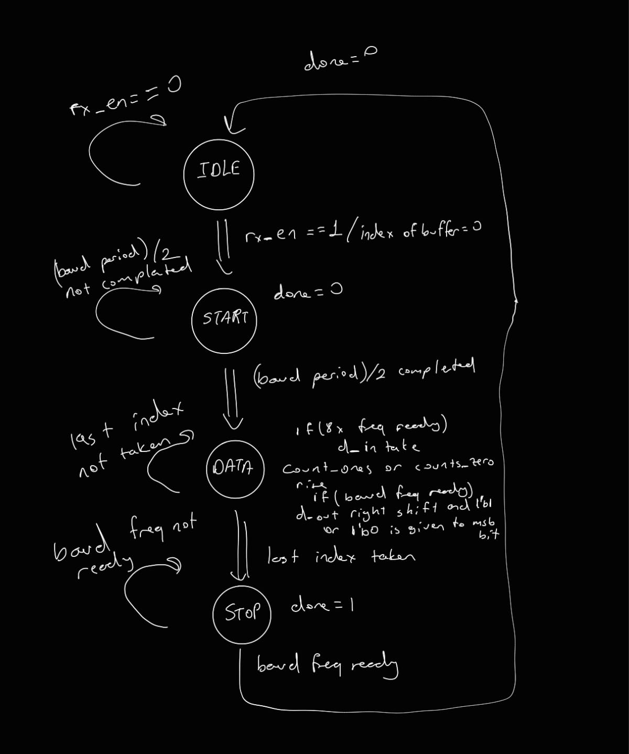

  - Simulation Source
module uart_rx_tb;

// Parameters
parameter freq = 115200;
// Bit period for 115200 baud: 1,000,000,000 / 115200 = 8680 ns
localparam BIT_PERIOD = 8680;

// Testbench Signals
reg clk = 0;
reg rst = 0;
reg d_in = 1; // Rx line is IDLE High
reg rx_en = 0;

// Outputs from DUT
wire [7:0] d_out;
wire done;
wire start; // Added to match DUT
wire busy; // Added to match DUT

// Test Variables
reg [7:0] test_data;
reg [7:0] expected_data;
integer file, i, r;

// Clock Generation (100 MHz, 10ns period)
always #5 clk = ~clk;

// Instantiate the Unit Under Test (UUT)
uart_rx #(
.freq(freq)
) uut (
.clk(clk),
.rst(rst),
.d_in(d_in),
.rx_en(rx_en),
.d_out(d_out),
.start(start), // Connected for observation
.busy(busy), // Connected for observation
.done(done)
);

// Task: Simulate UART Serial Transmission
// Sends one byte of data serially on 'd_in' line
task send_uart_byte(input [7:0] para_in);
integer k;
begin
// 1. Send Start Bit (Low)
d_in = 0;
#BIT_PERIOD;

// 2. Send Data Bits (LSB to MSB)
for (k = 0; k < 8; k = k + 1) begin
d_in = para_in[k];
#BIT_PERIOD;
end

// 3. Send Stop Bit (High)
d_in = 1;
#BIT_PERIOD;
end
endtask

// Main Test Sequence
initial begin
// 1. Open File
file = $fopen("stimulus2.txt", "r");
if (file == 0) begin
$display("Error: Cannot open stimulus2.txt");
$finish;
end

$display("Starting UART RX testbench...");

// 2. Reset System
rst = 1;
#10000;
rst = 0;
rx_en = 0;
#45;

i = 0;

// 3. Read loop
// Uses $fscanf return value 'r' to ensure safe file reading
while (!$feof(file)) begin
r = $fscanf(file, "%b\n", test_data);

if (r == 1) begin // Process only if read was successful
expected_data = test_data;

// Enable Receiver
rx_en = 1;

// Send Data via Task
send_uart_byte(test_data);

// Wait a bit to ensure 'done' signal is caught
#100;

// Check Result
if (d_out == expected_data) begin
$display("Test %0d Passed! Sent: %b, Received: %b", i + 1, expected_data, d_out);
end else begin
$display("Test %0d Failed! Sent: %b, Received: %b", i + 1, expected_data, d_out);
end

// Disable Receiver briefly between bytes
rx_en = 0;
#60;

i = i + 1;
end
end

$display("Test completed!");
$fclose(file);
$finish;
end

endmodule

The UART receiver is verified using a self-checking testbench. The purpose of the testbench is to apply serial UART frames to the receiver input and to automatically check whether the reconstructed parallel output matches the expected values.
First, a 100 MHz clock is generated to drive the design under test. After reset is released, the receiver is enabled by asserting the rx_en signal. The baud rate parameter is set according to the selected baud value used in the design.
The testbench reads a sequence of input bytes from an external text file using file I/O system tasks. Each byte is stored in a variable and is then transmitted serially to the receiver input (d_in) by means of a dedicated task. This task generates a valid UART frame by:
- driving the line low for one bit period to represent the start bit,
- sending the 8 data bits in LSB-first order, each for one bit period, and
- driving the line high for one bit period to generate the stop bit.
During reception, the testbench waits for the done signal from the receiver, which indicates that a full byte has been reconstructed. The received output d_out is then compared against the expected value read from the file. If both values match, a “Passed” message is printed to the simulation console; otherwise, a “Failed” message is reported together with the sent and received data.
This approach allows the receiver to be tested automatically for multiple input patterns without manual inspection of the waveform. The simulation results confirm that the UART receiver correctly detects the start bit, performs oversampling, reconstructs the parallel data, and asserts the done signal after each valid frame.

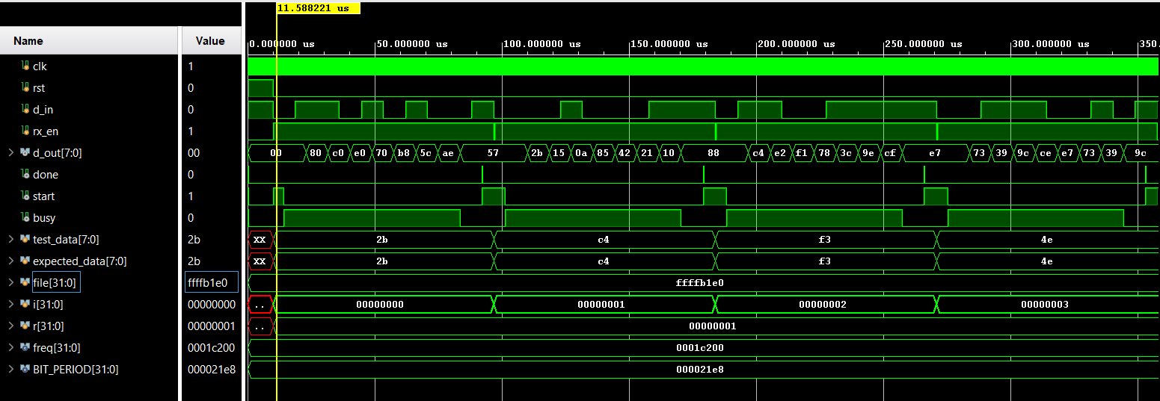
  - Simulation Waveform

Figure 9: UART receiver simulation waveform showing start-bit detection, T/2 alignment, 8x oversampling during data reception, and the reconstructed parallel output d_out with done pulses.

In the receiver simulation, serial data frames are applied to the d_in input using the testbench, while rx_en is asserted. As shown in Figure X, the receiver detects the falling edge of the start bit and waits for half a bit duration (T/2) to align sampling to the bit center. Then, in the DATA state, the input is sampled eight times per bit and the bit value is determined by majority voting.
After eight data bits are reconstructed, the receiver checks the stop bit and produces a one-cycle done pulse. The parallel output d_out matches the expected values (0x2B, 0xC4, 0xF3, and 0x4E), verifying correct operation of the UART receiver.

- TOP Module
  - Design Source
module uart_top #(
parameter [16:0] BAUD = 115200
)(
input wire clk, // 100 MHz system clock
input wire rst, // active-high reset
input wire [7:0] tx_data, // byte to be transmitted
input wire tx_en, // start TX
input wire rx_en, // enable RX

output wire [7:0] rx_data, // received byte
output wire tx_done,
output wire rx_done,
output wire tx_start,
output wire rx_start,
output wire tx_busy,
output wire rx_busy,
output wire tx_out // exposed serial line (loopback)
);

// Loopback serial line: TX output is directly connected to RX input
wire uart_line;

// -------------------------
// Transmitter Instance (TX)
// -------------------------
// baud_gen is instantiated inside uart_tx in this version
uart_tx #(
.freq(BAUD)
) u_tx (
.clk (clk),
.rst (rst),
.d_in (tx_data),
.tx_en (tx_en),
.seri_out(uart_line),
.start (tx_start),
.busy (tx_busy),
.done (tx_done)
);

// -------------------------
// Receiver Instance (RX)
// -------------------------
// baud_gen is instantiated inside uart_rx in this version
uart_rx #(
.freq(BAUD)
) u_rx (
.clk (clk),
.rst (rst),
.d_in (uart_line),
.rx_en(rx_en),
.d_out(rx_data),
.start(rx_start),
.busy (rx_busy),
.done (rx_done)
);

// Expose the internal serial line for observation in simulation
assign tx_out = uart_line;

endmodule

The uart_top module integrates the UART transmitter and receiver into a single loopback structure. The transmitter output is directly wired to the receiver input through an internal serial line, enabling end-to-end verification of UART transmission and reception. Separate enable signals are used to control transmission (tx_en) and reception (rx_en).
In this implementation, the baud rate generation is handled internally by the uart_tx and uart_rx modules (each module includes its own baud generator logic). The receiver uses an oversampled timing reference (8x baud) for reliable sampling, while the transmitter uses the baud timing to advance the frame bits. This top-level integration allows verifying the UART link by transmitting a byte and checking that the same byte is reconstructed at the receiver output.

  - Simulation Source

module uart_top_tb;

// -------------------------
// Parameters
// -------------------------
parameter [16:0] BAUD = 115200;

// -------------------------
// TB Signals
// -------------------------
reg clk = 1'b0;
reg rst = 1'b0;
reg [7:0] tx_data;
reg tx_en = 1'b0;
reg rx_en = 1'b0;

wire [7:0] rx_data;
wire tx_done;
wire rx_done;
wire tx_busy;
wire rx_busy;
wire tx_start;
wire rx_start;
wire tx_out;

// -------------------------
// File I/O & stimulus storage
// -------------------------
integer k;
integer fd;
integer rc;

reg [7:0] stim_mem [0:3];

// -------------------------
// DUT: UART loopback top
// -------------------------
uart_top #(
.BAUD(BAUD)
) dut (
.clk (clk),
.rst (rst),
.tx_data (tx_data),
.tx_en (tx_en),
.rx_en (rx_en),
.rx_data (rx_data),
.tx_done (tx_done),
.rx_done (rx_done),
.tx_start (tx_start),
.rx_start (rx_start),
.tx_busy (tx_busy),
.rx_busy (rx_busy),
.tx_out (tx_out)
);

// -------------------------
// 100 MHz clock
// -------------------------
always #5 clk = ~clk;

// -------------------------
// Main test sequence
// -------------------------
initial begin
// 1) Read stimulus file (4 bytes)
fd = $fopen("stimulus2.txt", "r");
if (fd == 0) begin
$display("ERROR: stimulus2.txt could not be opened.");
$finish;
end

for (k = 0; k < 4; k = k + 1) begin
rc = $fscanf(fd, "%b\n", stim_mem[k]);
end
$fclose(fd);

// 2) Reset sequence
$display("Starting UART Loopback Test...");
rst = 1'b1;
#20000;
rst = 1'b0;
tx_en = 1'b0;
rx_en = 1'b0;

// 3) Run tests
for (k = 0; k < 4; k = k + 1) begin
// Apply new input byte
tx_data = stim_mem[k];

// Enable RX before triggering TX
rx_en = 1'b1;

// Start TX (1 clk pulse is enough)
tx_en = 1'b1;
#10;
tx_en = 1'b0;

// Wait for RX completion
wait (rx_done == 1'b1);

// Give one extra clk edge to avoid sampling an old rx_data value
@(posedge clk);

// Check results
if (rx_data == stim_mem[k]) begin
$display("Test %0d PASS: Sent=%b (%h), Received=%b (%h)",
k+1, stim_mem[k], stim_mem[k], rx_data, rx_data);
end else begin
$display("Test %0d FAIL: Sent=%b (%h), Received=%b (%h)",
k+1, stim_mem[k], stim_mem[k], rx_data, rx_data);
end

// Prepare for next test
rx_en = 1'b0;
#20000;
end

$display("All tests completed.");
$finish;
end

endmodule

The uart_top_tb testbench generates the system clock and reset, reads stimulus bytes from a text file, and applies them to the UART transmitter. By enabling the receiver and triggering the transmitter, the testbench verifies the loopback connection between TX and RX. For each transmitted frame, the receiver output is compared against the expected value and pass/fail messages are reported, enabling automated functional verification of the complete UART system.

  - Simulation Waveform

    - Behavioral Simulation:
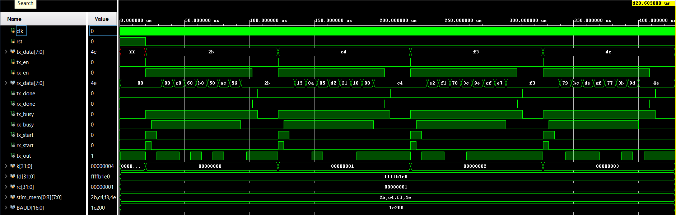

Figure 13: Behavioral simulation waveform of the UART top module showing loopback transmission and reception of four bytes with corresponding tx_done and rx_done pulses.

Figure 13 shows the behavioral simulation results of the uart_top module configured in loopback mode. The input bytes read from the stimulus file are applied to the transmitter through tx_data while tx_en is asserted. For each test case, the transmitter generates a UART frame consisting of a start bit, eight data bits, and a stop bit, which appears on the serial line tx_out. This serial stream is directly fed into the receiver input. When a complete frame is received, the receiver reconstructs the parallel byte at rx_data and asserts the rx_done signal. The waveform demonstrates that for all transmitted values (0x2B, 0xC4, 0xF3, and 0x4E), the received data matches the transmitted data, confirming correct end-to-end operation of the UART loopback system.

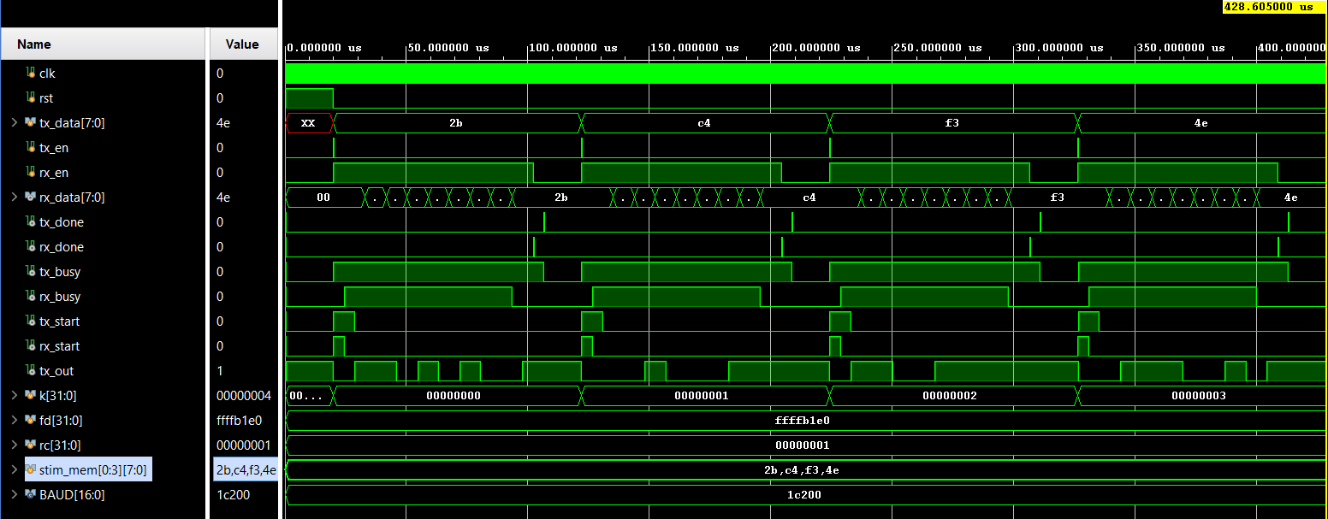
    - Post-implementation Timing Simulation

Figure 14: Post-implementation timing simulation of the UART top module showing correct loopback operation with gate-level delays.

Figure 14 shows the post-implementation timing simulation results of the uart_top module after place-and-route. In this simulation, the synthesized and routed netlist is used together with timing delays, providing a realistic representation of hardware behavior. Despite the presence of propagation delays, the transmitter successfully generates UART frames on the serial line tx_out, and the receiver correctly reconstructs the transmitted bytes at rx_data. The tx_done and rx_done signals are asserted for each frame, indicating proper completion of transmission and reception. The results demonstrate that the UART top module operates correctly not only at the behavioral level but also after implementation with actual timing effects.

